**Task SQL**

Database : db_company.sql

5. Relasi antar table

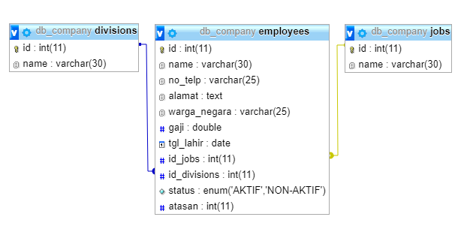

Foreign key :

|  |
| --- |
| ALTER TABLE employees  ADD CONSTRAINT fk_id_divisions_new  FOREIGN KEY (id_divisions)  REFERENCES divisions(id)  ON DELETE CASCADE ON UPDATE CASCADE;  ALTER TABLE employees  ADD CONSTRAINT fk_id_jobs_new  FOREIGN KEY (id_jobs)  REFERENCES jobs(id)  ON DELETE CASCADE ON UPDATE CASCADE; |

6. Relasi untuk mengetahui atasan dan bawahan

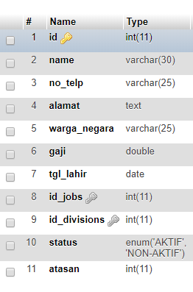

7. Query menampilkan orang yang bekerja sebagai developer divisi dimana orang tersebut bekerja :

|  |
| --- |
| SELECT employees.id , employees.name , divisions.name AS Division, jobs.name AS Jobs  FROM employees INNER JOIN divisions  ON employees.id_divisions = divisions.id  INNER JOIN jobs  ON employees.id_jobs = jobs.id WHERE jobs.name ='Developer'; |
| Hasil Pengujian : |

8. Query untuk menampilkan atasan Udin bekerja di divisi mana dan pekerjaan nya :

|  |
| --- |
| SELECT employees.id , employees.name , divisions.name AS Division,  jobs.name AS Jobs, employees.atasan  FROM employees INNER JOIN divisions  ON employees.id_divisions = divisions.id  INNER JOIN jobs  ON employees.id_jobs = jobs.id ORDER BY employees.atasan ASC; |
| Hasil pengujian :    Keterangan : 0 menyatakan atasa dari semua karyawan |

9. Query untuk menampilkan bawahan Udin bekerja di divisi mana dan pekerjaan nya :

|  |
| --- |
| SELECT employees.id , employees.name , divisions.name AS Division,  jobs.name AS Jobs, employees.atasan  FROM employees INNER JOIN divisions  ON employees.id_divisions = divisions.id  INNER JOIN jobs  ON employees.id_jobs = jobs.id ORDER BY employees.atasan DESC; |
| Hasil Pengujian : |

10. Perbedaan Where, Having, Group BY

a. Where

|  |
| --- |
| -- Where  SELECT id, name FROM employees where name LIKE 'r%'; |
|  |

b. Having

|  |
| --- |
| SELECT count(id)  FROM employees  GROUP BY warga_negara  HAVING count(id); |
|  |

c.Group By

|  |
| --- |
| SELECT id, name FROM employees GROUP BY id DESC; |
|  |